Report On Heart Attack Possibility Using R

This is a report based the dataset based in Cleveland. This report is just the analysis of the writer and may vary from ane to other. So starting with the report, this dataset contains 14 columns namely:
1) age = tells about the age of the person
2) sex = tells about the gender of a person
3) chest pain type (4 values) = tells us that there are four types of chespains and what pain is experienced by a particular person
4) resting blood pressure = tells us about the blood pressure of a person
5) serum cholestoral in mg/dl = tells us about the cholestoral levels in a person
6) fasting blood sugar > 120 mg/dl = tells us about the sugar levels in a person
7) resting electrocardiographic
results (values 0,1,2) = tells about the cardio condition of a person
8) maximum heart rate achieved = tells about the maximum heart rate achieved by a person
9) exercise induced angina = tells about the exxercise induced pain for a person
10) oldpeak = ST depression induced by exercise relative to rest
11) the slope of the peak exercise
ST segment = gives the slope of the peak exercise
12) number of major vessels (0-3)
colored by flourosopy = gives the type of major vessels
13) thal: 0 = normal; 1 = fixed defect; 2 = reversable defect
14) target: 0= less chance of heart attack 1= more chance of heart attack

Story:
So this story is about a Hero and how he uses his intelligence to overcome a particular obstacle for the betterment of this world.
Once upon a time in the 21th century there lived a scientist named Chandra Kanth. As he was completing his higher studies there has been an outbreak which was leaving the world with no answers. So he decided to do his part in helping the world overcome this dangerous outbreak. He started doing research on this disease the cause for its origin, how it effects the humans, and so on. As he started his research he came up with some mind numbing results. As he collected information from his locality he came to find that this disease was more deadly on the females and also as he went on collecting the data he also had to do research on the chemistry of human body such as cholestoral levels and suger levels and many more.
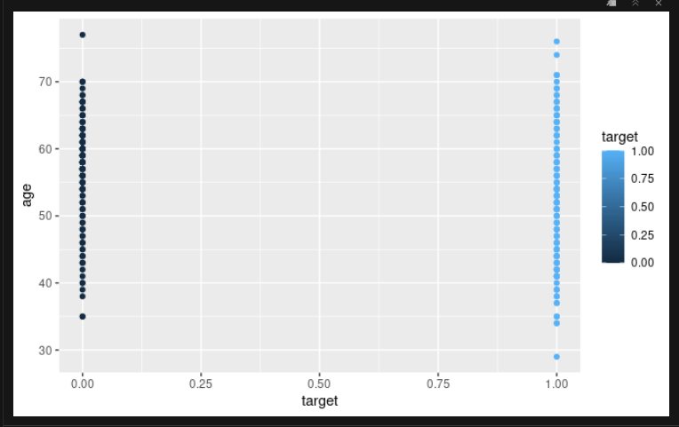
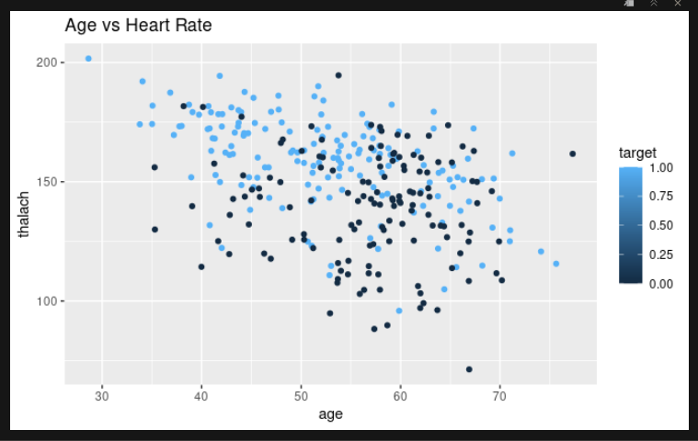
As it was an era which was seeing an emergance of a new technology called Big Data Analysis, he has started performing some tests on this data he came to know that irrespective of the age people are getting effected to this disease. He also found an intresting fact that for people with higher heart rate ie heart rate > 150 are found to be effected by this disease irrespective of the age.

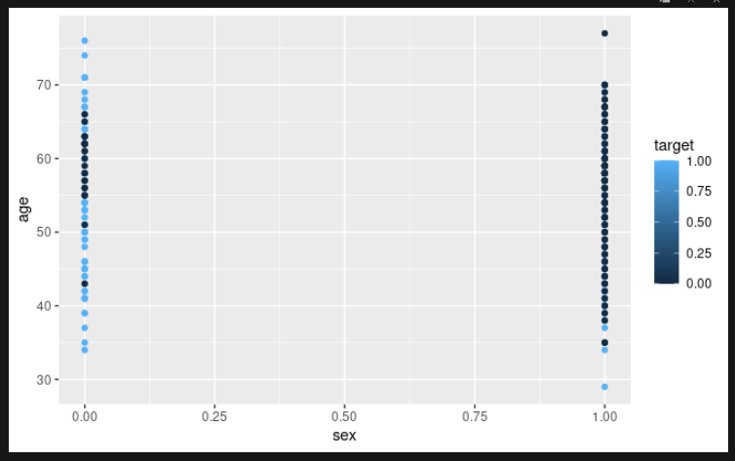
So these plots tell about the results obtained by Chandra Kanth were obviously true.Now he wanted to develope a linear model which would make predictions from experimental data. They can help in understanding and predicting the behavior of complex systems or analyze experimental, financial, and biological data.
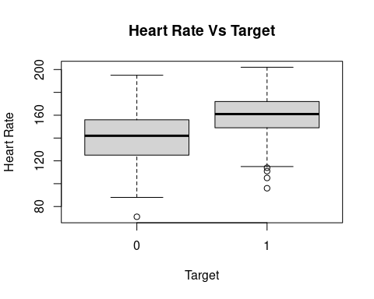

So as he was developing a linear model and performing different tests on his data to improve his models he went through a lot of difficulties and was finally able to overcome them with the help of his fellow scientists. At last he was able to help the world in his own way and in his capacity of how he can help make the world a better place.

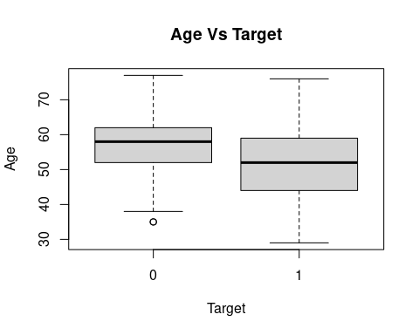
After much experimenting with the different variables Chandra Kanth came up with set of varibles which he thought might be the best model for predicting the diseased in less time through logistic regression.At first he divided the dataset into train and test sets in 70:30 ratio and started predicting on the train sets. After improving the accuracy , specificity and sensitivity he started to predict on his test sets and was satisfied with his results. He got accuracy at around 83% which at that time given his abilities to analysis the data was huge.
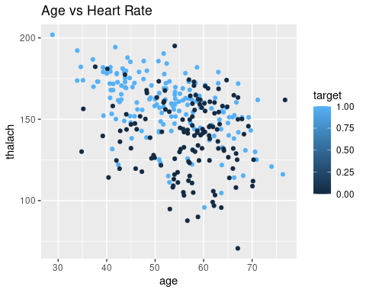
So in this way he was able to help the people with his abilities in whatever capacity he can and the people too are grateful for his work.
THE END

